Dear Reader,

Please find attached to this assignment the following items:

1. CS6120_NLP_Assignment_1_Notebook_Saleh-Alkhalifa.ipynb
2. text_classifier.py
3. loglikelihood.json

You can access the ‘.ipynb’ using Jupyter notebook and opening the file. You can run the text_classifier module by running the command “python text_classifier.py” This will require the loglikelihood.json file to be loaded in an “artifacts” file. An example of the file running on the command line can be seen below:

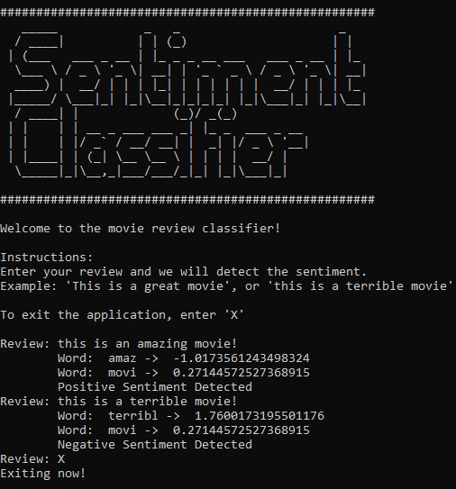

My full code and readme.md can be found on my personal GitHub: <https://github.com/alkhalifas/cs-6120-natural-language-processing/tree/master/Assignments/Assignment%201>